Name: Parth Sunil Satokar

PRN: 21070521113

Subject: GenAI

CA-2 Assignment

Q:2 Generate a model in Python to represent a Housing loan scheme and create a chart to display the Emi based on rate of interest and reducing balance for a given period. If a customer wishes to close the loan earlier, print the interest lost distributed over the remaining no. Of months. Assume suitable data and inputs as necessary.

Solution:

1.Import Libraries: numpy for numerical operations and matplotlib.pyplot for plotting.

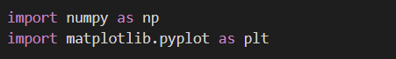

2.Function **calculate_emi**: Calculates the monthly EMI using the reducing balance method based on the principal, annual interest rate, and loan tenure.

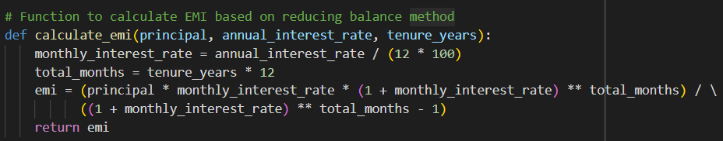

3.Function **early_closure**: Simulates loan payments month-by-month, calculates the total interest paid, and determines the interest lost if the loan is closed early (before the full tenure).

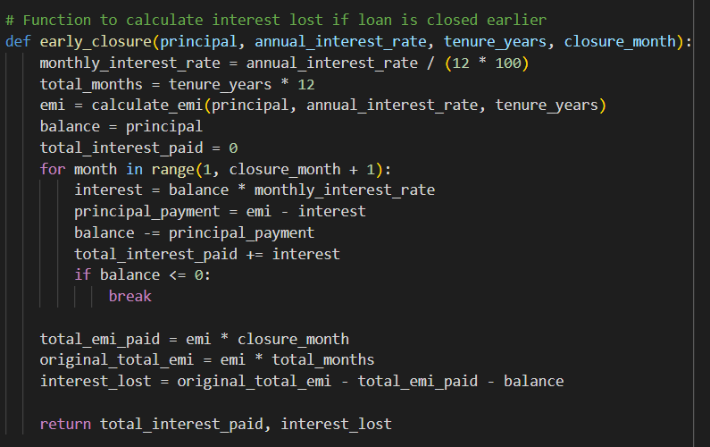

4.Function **plot_emi_vs_interest_rate**: Plots a graph showing how EMI changes with varying interest rates.

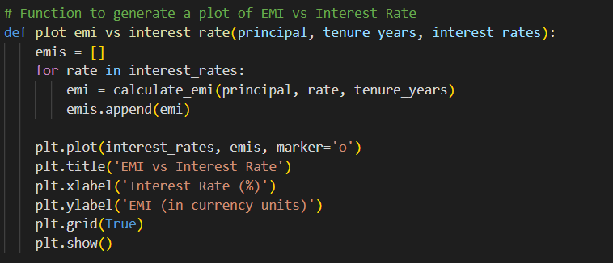

5.Main Execution:

* Uses sample inputs (₹500,000 loan, 20-year tenure, 7.5% interest rate, closure after 10 years).

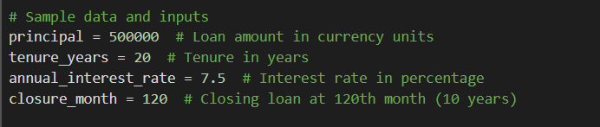

* Calculates and prints the monthly EMI, total interest paid until early closure, and interest lost.

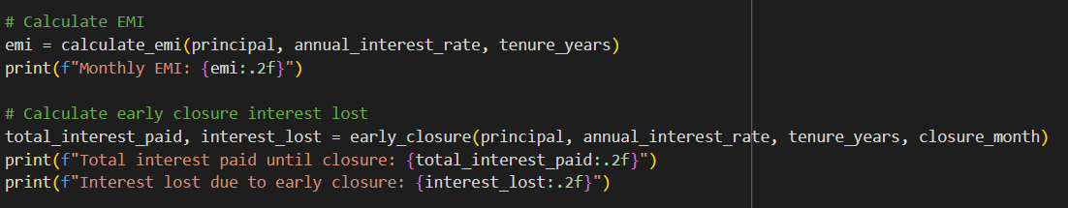

* Plots EMI vs. interest rate for rates between 6% and 12%.

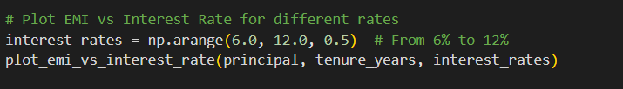

Output:

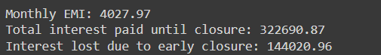

Graph:

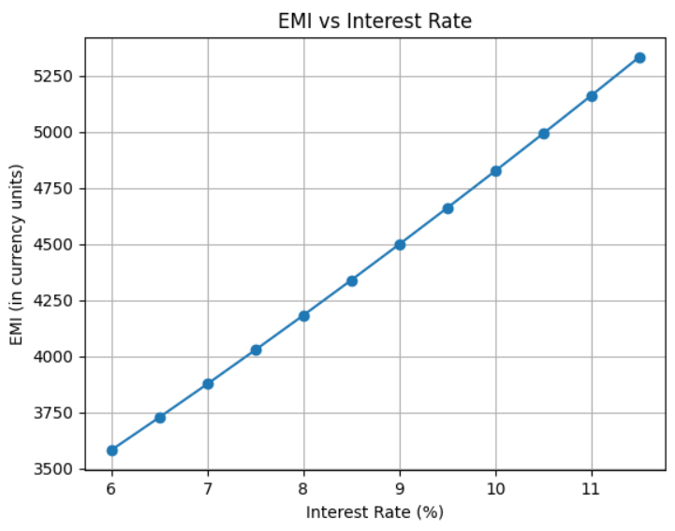

Q:6 Generate a model to represent a mathematical equation, write a program to parse the equation, and ask for input for each parameter.

Solution:

1.Import Library: Import the re module to help find variables in the equation using regular expressions.



2.Parse the Equation (parse_equation function):

* Find all variables (e.g., m, x, b) in the equation, except y, by extracting letters.
* Return a list of unique variables.

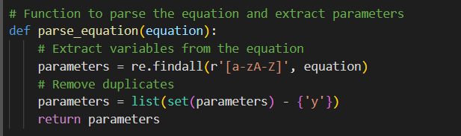

3.Get User Input & Evaluate (evaluate_equation function):

* Ask the user to input values for each variable.
* Replace the variables in the equation with these values. Use eval() to compute the result of the equation.

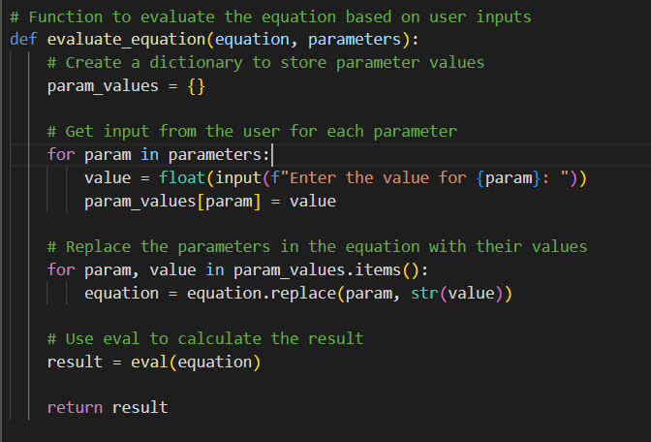

4.Main Program:

* Define the equation y = m*x + b.
* Parse the equation to get the variables (m, x, b). Ask the user for the values of these variables, evaluate the equation, and print the result.

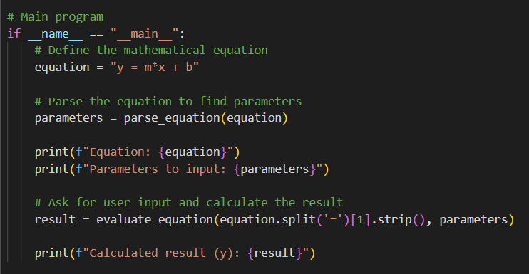

Output:

